**Advance Excel Assignment 3**

1. How and when to use the AutoSum command in excel?

Ans. If you need to sum a column or row of numbers. Select a cell next to the numbers you want to sum, click AutoSum on the Home tab, press Enter, and it’s done.

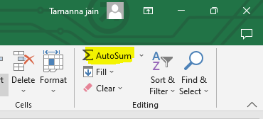

When you click AutoSum, Excel automatically enters a formula (that uses the SUM function) to sum the numbers.

Here’s an example. To add the January numbers in this Entertainment budget, select cell B7, the cell immediately below the column of numbers. Then click AutoSum. A formula appears in cell B7, and Excel highlights the cells you’re totaling.

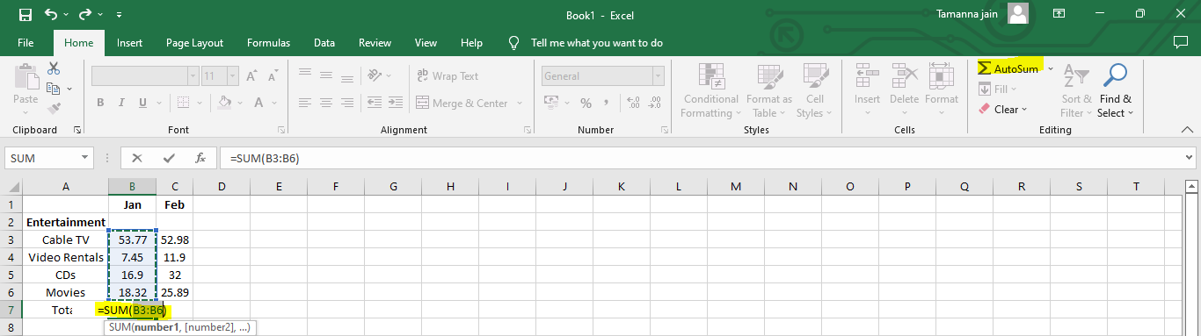

Press Enter to display the result (96.44) in cell B7. You can also see the formula in the formula bar at the top of the Excel window.

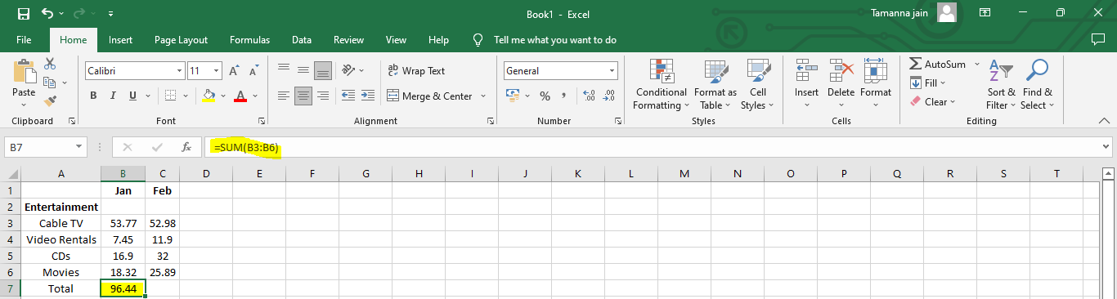

1. What is the shortcut key to perform AutoSum?

Ans. **Alt+=** is the shortcut key to perform AutoSum.

1. How do you get rid of Formula that omits adjacent cells?

Ans. The **Excel formula omits adjacent cells** error can occur with mathematical or statistical functions, such as **SUM, AVERAGE, COUNT, MIN, MAX.**

This error appears when there are cells with similar values to the one, we chose that are not selected. Excel recognizes it as an error and symbolizes it with a little triangle.

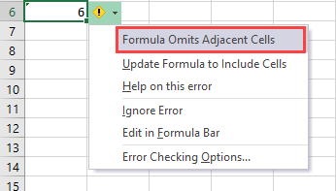

* There are a few ways to make this error disappear :
* Change formulas to have B5 and C2 cells included.
* Remove [values from cells](https://officetuts.net/excel/formulas/get-cell-value/) B5 and C2.
* Click the ignore error option. You have to do it for each formula.

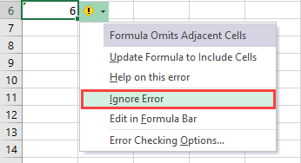

* Getting rid of this error permanently
* To do it, go to **File >> Options >> Formulas**.

On the right side, under **Error checking rules** uncheck the field called **Formulas which omit cells in a region**.

After user make this change, Excel will stop irritating user with this error message.

1. How do you select non-adjacent cells in Excel 2016?

Ans. **Select Non-Adjacent Cells with Keyboard and Mouse :**

With your mouse, click the first cell you want to highlight. This cell becomes the [active cell](https://www.lifewire.com/active-cell-definition-3123375).

Press and hold the **Ctrl**key on the keyboard.

Click the rest of the cells you want to highlight.

Once the desired cells are highlighted, release the**Ctrl**key.

Do not click anywhere else with the mouse pointer once you release the **Ctrl** key or you will clear the highlight from the selected cells.

If you release the **Ctrl** key too soon and wish to highlight more cells, press and hold the **Ctrl** key again and click the additional cells.

**Use Only the Keyboard to Select Non-Adjacent Cells :**

To select non-adjacent cells with only the keyboard requires you to use the keyboard in Extended mode. Extended mode is activated by pressing the **F8** key on the keyboard. You can shut off extended mode by pressing the **Shift**and **F8**keys on the keyboard together.

Move the cell cursor to the first cell you want to highlight.

Press and release the **F8**key on the keyboard to start Extended mode and to highlight the first cell.

Without moving the cell cursor, press and release the **Shift**+**F8** keys on the keyboard together to shut off Extended mode.

Use the arrow keys on the keyboard to move the cell cursor to the next cell you wish to highlight. The first cell remains highlighted.

With the cell cursor on the next cell to be highlighted, repeat steps 2 and 3 above.

Continue to add cells to the highlighted range by using the **F8** and **Shift**+**F8** keys to start and stop Extended mode.

1. What happens if you choose a column, hold down the Alt key and press the letters ocw in quick succession?

Ans. If userhold down the Alt key and press the letters ocw in quick succession**,** The column width dialogue box opens allowing you to set the exact width of the column. You can insert a value in the column width dialogue box for how wide you would like a column to be. This is especially useful if we have several non-adjacent columns that we need to be the same width.

1. If you right-click on a row reference number and click on Insert, where will the row be added?

Ans. If we right-click on a row reference number and click on Insert, the row will be added on the above of that row which we selected.